How to run ionic Angular project?

Local: c: ngMileageApp/www

1. Open Git,
2. 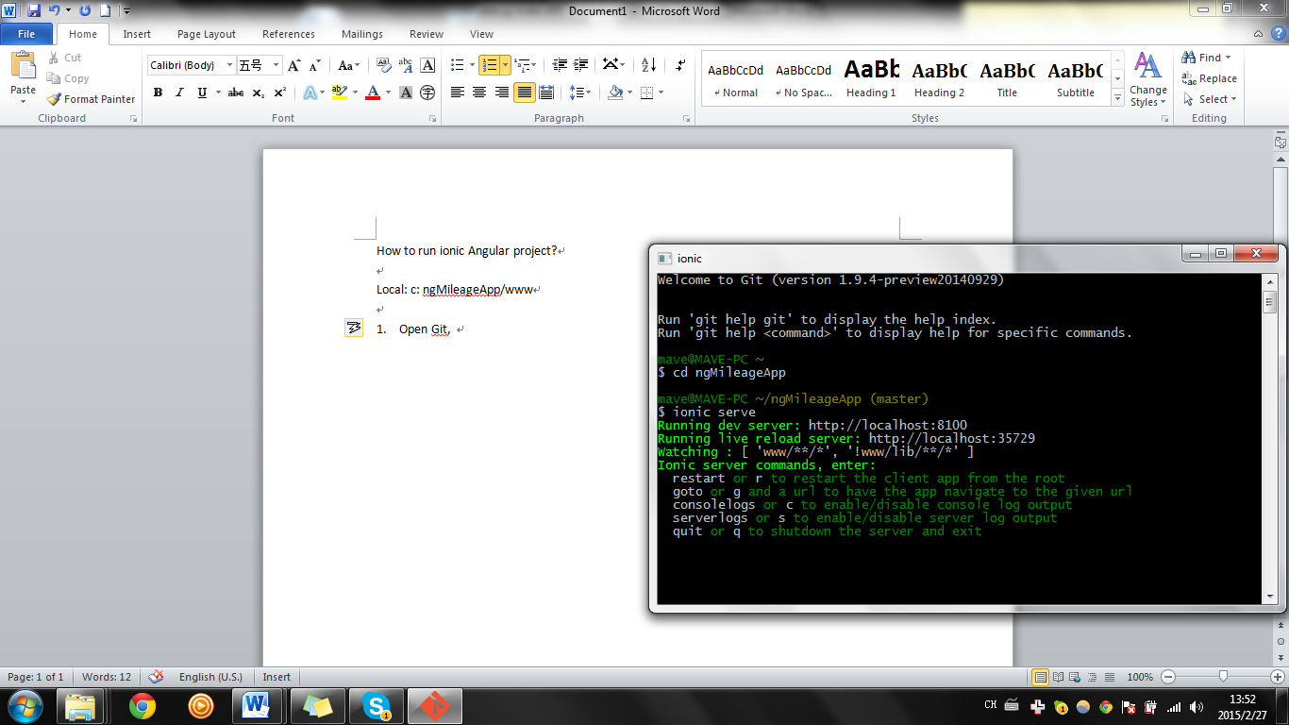
3. On command line: cd ngMileageApp (have)
4. Then: type in ionic serve
5. The screen pops up.